Title of your paper
First Author1¹ | Institute AA
Second Author | University of BB
This is a template to be used to prepare a suitably formatted submission for the Journal, “Attention and Cognition”. It contains instructions, style definitions, and illustrations of the use of those styles. It also includes the section headings that we suggest. This is the text of the abstract. It has the style A&CAbstract.
Keywords: high level vision, attention, visual cognition, simulation models, research database.

Purpose
This template includes the following styles, which should be used where possible.
A&CTitle
A&CAuthor
A&CAffiliation
A&CAbstract
A&CKeywords
A&CBodyText
A&CBodyTextContinue
A&CHeading1
A&CHeading2
A&CHeading3
A&CFigure
A&CFootnoteNumber1
A&CReference
A&CCaption
A&CTable
A&CTableCaption
A&CEquation
A&CBlockText
A&CHeader
A&CAbstract
A&CList
A&CNumberedList
To create a new manuscript
To create a new manuscript for “Attention and Cognition” proceedings, follow these steps.
- 1. Open the template from MS Word.
- 2. Save it as a different file name.
- 3. Fill the contents and apply the above styles where applicable.
To apply templates to an existing manuscript
To apply templates to an existing manuscript, follow these steps.
- 1. Open this template from MS Word.
- 2. Position the cursor at the start of the file.
- 3. From "Insert" menu, choose "File" and select the rtf file of your existing manuscript. Its contents will be inserted at the location of the cursor.
- 4. Save the result under a new name.
- 5. Begin applying the styles as they are described in the template. If you are using a recent version of Word, and you are using a version of the template with a “.doc” extension, a toolbar should appear with many of the styles in it as buttons.
- The headings should have the styles A&CHeading1, A&CHeading2, A&CHeading3. The body text should have the style A&CBodyText.

Equations
Display equations
When we have a display equation, we use Equation Editor or MathType to create it, and use “Insert Equation Number”. The paragraph should have the style jovEquation.
$u_{i}\left(t\right)=\sum_{t_{i}^{(f)}∈F_{i}}{η_{i}\left(t−t_{i}^{(f)}\right)+\sum_{j∈Γ_{i}}{\sum_{t_{j}^{(f)}∈F_{j}}{w_{\text{ij}}ε_{\text{ij}}\left(t−t_{j^{(f)}}\right)}}}$ (1)
A paragraph following a display equation with a continuation of the sentence should have the style A&CbodyTextContinue.
In-Line Math
For math within a line of text, L(x,y,t) = wTI(x,y,t), use regular text and the symbol font wherever possible Where not possible, use Equation Editor or MathType.．
Results
Figures should be placed in the text using the “Insert Picture….From File” command, and the individual figure files should be preserved for the final submission of the manuscript.
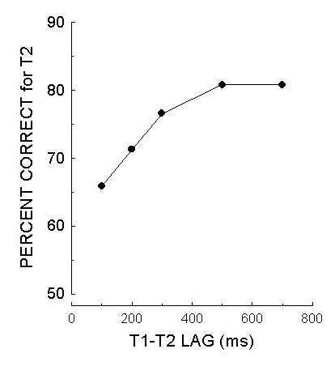
Figure 1. Figure captions should be inserted using the command, “Insert Caption”. The caption should have the style A&CCaption.

Block text like this should be used for program code or other literal text. It should be accompanied by a figure caption
Figure 2. This is an example of a caption for block text.
Discussion
Tables should be created with the “Insert Table” command. The caption should be created using the “Insert Caption” command. This command may be found somewhere else in the menu bar in Microsoft Word2000 or later.

Table 1. This caption should be given the style A&CTableCaption.
SOA(ms) | Trial type | Detection  Error (%) | Identification  Error (%)
0 | Valid | 26.2 | 32.6
0 | Invalid | 19.3 | 32.3
100 | Valid | 30.1 | 22.0
100 | Invalid | 33.2 | 44.8
200 | Valid | 19.9 | 11.8
200 | Invalid | 16.4 | 14.7

Conclusion
Your conclusion.
Appendix
If necessary.
Footnote
¹Footnote．
References
Kumada, T., & Humphreys, G. W. 2001 Lexical recovery from extinction: Interactions between visual form and stored knowledge modulate visual selection. Cognitive Neuropsychology, 18, 465-478.

